^{R Statistics with MongoDB} Statistical Functions
kmeans(dat, 4)

K-means clustering with 4 clusters of sizes 21, 18, 30, 31

Cluster means:
1 | [,1] | [,2]
1 | 0.7755 | 0.8509
2 | -0.1557 -0.2305
3 | 1.2299 | 1.1472
4 | 0.1510 | 0.1507

Clustering vector:

- 4 2 4 4 2 4 4 4 2 4 4 4 2 2 4 4 1 4 2

2 2 4 4 4 2 4 2 4 4 2 4 2 2 4 4
- 4 4 4 4 4 4 4 4 2 4 2 2 4 2 2 1 1 1 1

3 1 3 3 3 1 1 3 3 3 3 1 3 1 3 3
- 1 3 1 1 3 3 3 3 1 1 3 3 1 1 1 3 3 3 3

1 3 1 3 3 3 3 1 3 3 3

Within cluster sum of squares by cluster: [1] 3.318 1.166 4.019 3.195

(between_SS / total_SS = 83.0 %)

Available components:

[1] "cluster" "centers" "totss" "withinss"

[5] "tot.withinss" "betweenss" "size"


R Statistics with MongoDB

plot(dat, col = cl$cluster, cex=2, pch=16) points(cl$centers, col = 1:4, pch = 13, cex = 4)
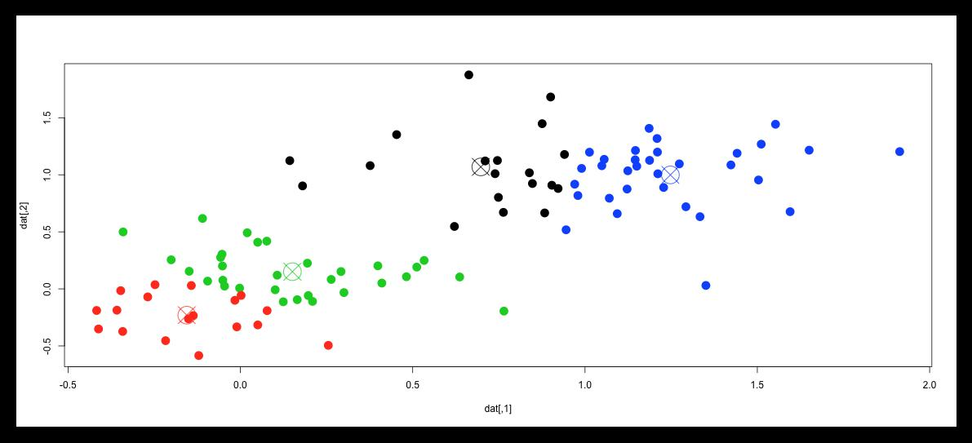

^{R Statistics with} R^{MongoDB}Shiny - easy web application

 developed by RStudio

turns R analyses into interactive web applications that anyone can use

let your users choose input parameters using friendly controls like sliders, drop-downs, and text fields

easily incorporate any number of outputs like plots, tables, and summaries

no HTML or JavaScript knowledge is necessary, only R

http://www.rstudio.com/shiny/

R Statistics with MongoDB

R and Databases

SQL provides a standard language to filter, aggregate, group, sort data

SQL in new places: Hive, Impala, …

ODBC provides SQL interface to non-database data (Excel, CSV, text files)

R stores relational data in data.frames (extended lists)


R Statistics with MongoDB

data(iris) head(iris, n=3)


Sepal.Length Sepal.Width Petal.Length

Petal.Width Species
1 | 5.1 | 3.5
1.4 | 0.2 | setosa
2 | 4.9 | 3.0
1.4 | 0.2 | setosa
3 | 4.7 | 3.2
1.3 | 0.2 | setosa

class(iris)

[1] "data.frame"

R Statistics with MongoDB | R package: sqldf

running SQL statements on R data frames


library(sqldf)

sqldf("select * from iris limit 2")


Sepal_Length Sepal_Width Petal_Length

Petal_Width Species
1 | 5.1 | 3.5
1.4 | 0.2 | setosa
2 | 4.9 | 3.0
1.4 | 0.2 | setosa
sqldf("select count(*) from iris")
count(*) 1 150

^{R Statistics with MongoDB}Other relational R package

RMySQL package provides an interface to MySQL

RPostgreSQL package provides an interface to PostgreSQL

ROracle package provides an interface for Oracle

RJDBC package provides access to databases through a JDBC interface

RSQLite package provides access to SQLite (SQLite engine is included)

One big problem:

all packages read the full result in R memory

R Statistics with MongoDB | R and MongoDB

on CRAN there are two packages to connect R with MongoDB

rmongodb supported by MongoDB, Inc.

 powerful for big data

difficult to use due to BSON objects

RMongo

easy to use

limited functionality

reads full results in R memory does not work on MAC OS X

R Statistics with MongoDB | R package: RMongo


library(Rmongo)

mongo <- mongoDbConnect("cc_JwQcDLJSYQJb", "dbs001.mongosoup.de", 27017) dbAuthenticate(mongo, username="JwQcDLJSYQJb", password="RSXPkUkXXXXX")


dbShowCollections(mongo) dbGetQuery(mongo, "zips","{'state':'AL'}") dbInsertDocument(mongo, "test_data", '{"foo": "bar", "size": 5 }')
dbDisconnect(mongo)

R Statistics with MongoDB _{R package: rmongodb}

developed on top of the MongoDB supported C driver

library(rmongodb) mongo <-

mongo.create(host="dbs001.mongosoup.de", db="cc_JwQcDLJSYQJb", username="JwQcDLJSYQJb", password="RSXPkUkXXXXX")
mongo

[1] 0 attr(,"mongo")

<pointer: 0x105a1de80> attr(,"class")
[1] "mongo" attr(,"host")
[1] "dbs001.mongosoup.de" attr(,"name")
[1] "" attr(,"username") [1] "JwQcDLJSYQJb" attr(,"password") [1] "RSXPkUkxRdOX" attr(,"db")
[1] "cc_JwQcDLJSYQJb" attr(,"timeout")
[1] 0

R Statistics with MongoDB

mongo.get.database.collections(mongo, "cc_JwQcDLJSYQJb")


[1] "cc_JwQcDLJSYQJb.zips" "cc_JwQcDLJSYQJb.ccp" "cc_JwQcDLJSYQJb.test"
mongo <- mongo.disconnect(mongo)

R Statistics with MongoDB

buf <- mongo.bson.buffer.create() mongo.bson.buffer.append(buf, "state", "AL")
[1] TRUE
query <- mongo.bson.from.buffer(buf) query
state : 2 AL

R Statistics with MongoDB

res <- mongo.find.one(mongo, "cc_JwQcDLJSYQJb.zips", query) res


city : 2 |  | ACMAR
loc : | 4 | -86.515570
0 | : 1 | -86.515570
1 | : 1 | 33.584132
pop : | 16 | 6055
state | : 2 | AL
_id : | 2 | 35004

R Statistics with MongoDB

out <- mongo.bson.to.list(res) out$loc
[1] -86.52 33.58
typeof(out$loc)
[1] "double"
out$pop
[1] 6055
out$state
[1] "AL"

R Statistics with MongoDB

cursor <- mongo.find(mongo, "cc_JwQcDLJSYQJb.zips", query)


res <- NULL

while (mongo.cursor.next(cursor)){ value <- mongo.cursor.value(cursor) Rvalue <- mongo.bson.to.list(value) res <- rbind(res, Rvalue)
}

err <- mongo.cursor.destroy(cursor)

head(res, n=4)


city | loc | pop | state
_id | Numeric,2 | 6055 | "AL"
Rvalue "ACMAR" | Numeric,2 | 6055 | "AL"
"35004" |  | 10616 "AL"
Rvalue "ADAMSVILLE" Numeric,2
"35005" | Numeric,2 | 3205 | "AL"
Rvalue "ADGER" | Numeric,2 | 3205 | "AL"
"35006" | Numeric,2 | 14218 | "AL"
Rvalue "KEYSTONE" | Numeric,2 | 14218 | "AL"
"35007"

^{R Statistics} about creating BSON query or field objects


b <- mongo.bson.from.list( list(name="Fred", age=29, city="Boston"))
b

name : | 2 | Fred
age : 1 |  | 29.000000
city : | 2 | Boston
mongo.bson.to.list(b)

$name

[1] "Fred"

$age [1] 29

$city

[1] "Boston"


?mongo.bson
?mongo.bson.buffer.append
?mongo.bson.buffer.start.array

?mongo.bson.buffer.start.object


buf <- mongo.bson.buffer.create() mongo.bson.buffer.append(buf, "aggregate", "zips") mongo.bson.buffer.start.array(buf, "pipeline")

mongo.bson.buffer.start.object(buf, "$group")
mongo.bson.buffer.append(buf, "_id", "$state")

mongo.bson.buffer.start.object(buf, "totalPop")
mongo.bson.buffer.append(buf, "$sum", "$pop")

mongo.bson.buffer.finish.object(buf) mongo.bson.buffer.finish.object(buf)
mongo.bson.buffer.start.object(buf, "$match") mongo.bson.buffer.start.object(buf,
"totalPop") mongo.bson.buffer.append(buf, "$gte",
"10000") mongo.bson.buffer.finish.object(buf)
mongo.bson.buffer.finish.object(buf) mongo.bson.buffer.finish.object(buf) query <- mongo.bson.from.buffer(buf)

^{R Statistics with MongoDB}CCP Web Analytics Challenge


buf <- mongo.bson.buffer.create() query <- mongo.bson.from.buffer(buf) buf <- mongo.bson.buffer.create()

err <- mongo.bson.buffer.append(buf, "user", 1)

err <- mongo.bson.buffer.append(buf, "type", 1)

field <- mongo.bson.from.buffer(buf) out <- mongo.find(mongo,
"cc_JwQcDLJSYQJb.ccp", query, fields=field, limit=1000)
res <- NULL
while (mongo.cursor.next(out)){ value <- mongo.cursor.value(out)
Rvalue <- mongo.bson.to.list(value) res <- rbind(res, Rvalue)
}

boxplot( as.integer(table(unlist(res[,2])) ), cex=4, horizontal=TRUE, main="Number of actions per user")
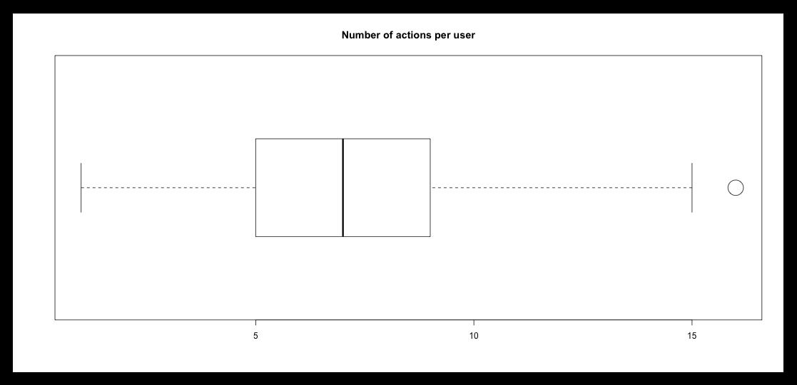

R Statistics with MongoDB
Shiny Mongo

R based MongoDB User Interface

R packages shiny and rmongodb

less than 200 lines of code DEMO: http://localhost:8100

https://github.com/comsysto/ShinyMongo

R Statistics with MongoDB

Summary

R is a powerful statistical tool to analyse many different kind of data

R can access databases

MongoDB and rmongodb ready for Big Data

start playing around with R, Big Data and MongoDB

http://www.r-project.org

http://www.mongodb.org

